REFLECT
What professional/personal competency would I like to develop?:
In this section, answer the following questions to help reflect on your professional strengths and opportunities for development. This section is designed to help you identify possible learning objectives to focus on for this 2-week CPD experience.
- What are some of my professional and/or personal needs and goals, both now and in the near future?

- What knowledge, skills, or behaviors do I need to work on to meet these professional and/or personal goals?

- In the last year, what situations highlighted an opportunity for further development?

- What have preceptors, supervisors, peers, faculty, or mentors suggested as possible areas of improvement?

PLAN
What do I want to do?:
In this section, use Bloom’s Taxonomy to describe at least two objectives you would like to achieve on this rotation. Remember, at least one must be patient care related. Explain the activities and resources you plan to utilize to achieve these objectives. This section should be completed by 4pm on Tuesday, April 7th, 2020.

 | Using verbs from Bloom’s Taxonomy, state your learning objective. | Planned activities and resources to be used to meet your learning objective. | Start Date | Planned End Date
Objective 1:
Objective 2:
Objective 3: (optional)

Bloom’s Taxonomy: https://mygrowthmindsethome.files.wordpress.com/2019/03/blooms-taxonomy.pdf
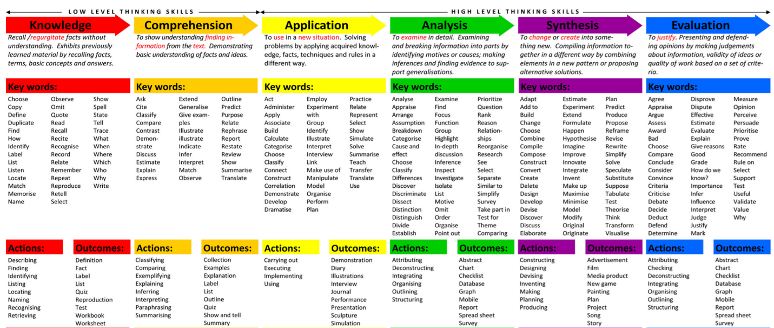

LEARN
What did I do?:
In this section, describe the activities used to achieve your objectives on this rotation. Explain the tools, methods, activities, and resources you employed to assist you in achieving your objectives. This section is to be completed as you work on your learning objectives.

 | Learning objective | What specific measures did I employ to accomplish my objectives? | Did I meet my objective? | Date Completed
Objective 1:
Objective 2:
Objective 3:
(optional)

EVALUATE
Through reflective writing, please discuss the following:
- Did you meet your learning objectives? Please describe.

- Are you are satisfied with your outcomes? Explain.

- Moving forward, would you like to continue with these learning goals, or would you prefer to create other objectives to focus on different areas of development? If you would like to create new objectives, what are some areas that you would like to focus on?

- What did you learn through this process?

RECORD:
In this section, include documentation of your activities throughout your process. Documentation can include photos, screenshots, pdf’s, excel spreadsheets, etc.

References:
Accreditation Council for Pharmacy Education. Introduction to My CPD. https://www.acpe-accredit.org/pdf/CPD/IntroductionMyCPD.pdf (accessed 2020 March 20).

Tofade T, Kim J, Lebovitz L, et al. Introduction of a Continuing Professional Development Tool for Preceptors: Lessons Learned. J Pharm Pract. 2015 Apr;28(2):212-9.
https://journals.sagepub.com/doi/pdf/10.1177/0897190014544813

https://mygrowthmindsethome.files.wordpress.com/2019/03/blooms-taxonomy.pdf

